HOTELS

DESTINATION | DATE | NIGHTS | HOTELS
NORTH GOA | 28 – 30 Dec | 2 | Aura Retreat, Arambol
 | 30 – 31 Dec | 1 | Houseboat, Siolim
SOUTH GOA | 31 Dec – 03 Jan | 3 | Bhakti Kutir / Ordo Sounsar
AROSSIM / BENAULIM | 03 – 07 Jan | 4 | Homestay/ AirBnB
 | Total Nights = | 10

FLIGHTS

SECTOR | DATE & DAY | NUMBER | NAME | TIMING
HEATHROW – GOA | 28 Dec Fri | ** – *** | ****** | **** / ****
GOA – ******* | 07 Jan Mon | ** - **** | ******* | **** / ****

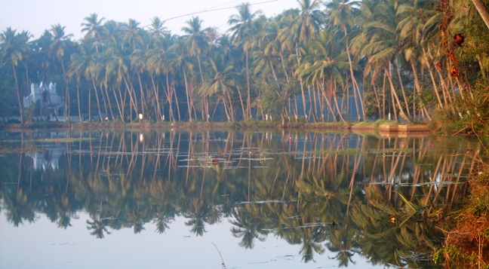

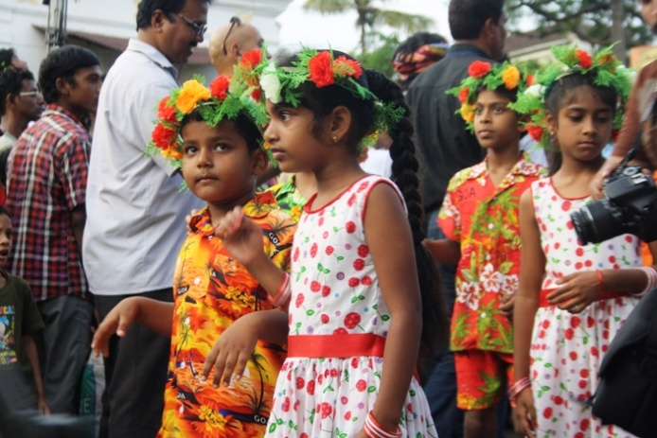
Date & Day Programme

28 Dec Fri HEATHROW – GOA

**** Arrive Goa – “The Pearl of East” & Transfer to the hotel

Evening enjoy the unparalleled sunset at the beautiful beach

Overnight at the hotel

29 Dec Sat NORTH GOA VISIT
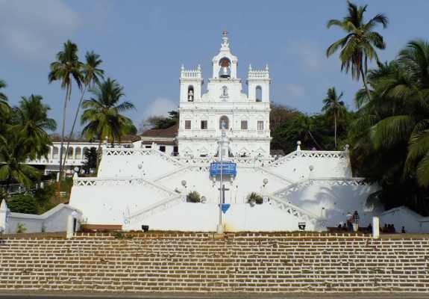
Breakfast at the hotel

Afternoon is free or if you like to do a long walk, can visit Fort Aguada & its Light House (about 2 km)

Enjoy sunset at the beach. There are plenty of nice restaurants to have an early dinner before heading back (on direct payment)

Overnight at the hotel

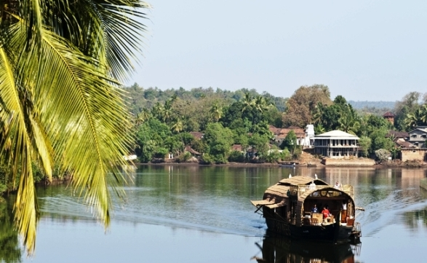
30 Dec Sun GOA – HOUSEBOAT

Breakfast at the hotel

First half is free to relax

Transfer to the Siolim jetty

1700 Board the houseboat and then cruise along the Chapora river and bask in the serenity of life in the Goan back waters, exploring river back farming, cockle fishing, and an incredible array of birds

Dinner & Overnight at the hotel

31 Dec Mon HOUSEBOAT – SOUTH GOA (Approx. 95 km / 2 & half hrs)

Breakfast at the hotel

1300 After Lunch, get down from the houseboat and transfer to South Goa, to Palolem en route visit Old Goa churches including Basilica of Bom Jesus, Fontainhas (Latin Quarters) in Panjim by feet, etc.

Evening enjoy the unparalleled sunset at the beach

Overnight at the hotel

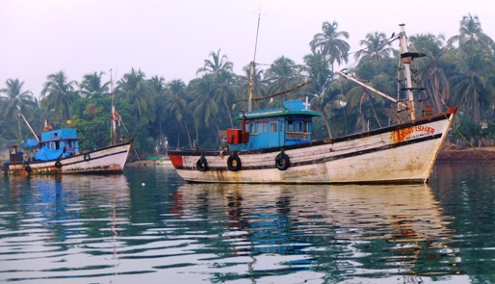
01 Jan Tue GOA – FISHING TRIP HAPPY NEW YEAR

Breakfast at the hotel

Half day fishing trip from Betul jetty, followed by lunch at the nearby restaurant, enjoy the freshly caught fish

Evening relax and enjoy sunset on the beach
Overnight at the hotel

02 Jan Wed SOUTH GOA VISIT
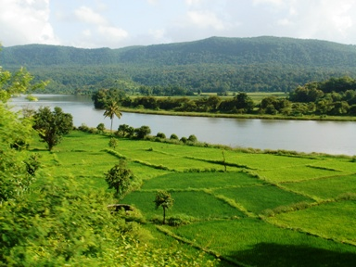
Breakfast at the hotel

This morning visit Goa Chitra & Goa Chakra, two different wings of same museum, having got old implements and tools as used in Goan households earlier, and for farming. The Chakra museum is a collection of various wooden bullock and camel carts from all over the country! Spend more time on own if you like……

Later drive to Southern part of Goa! Discover the historical Chandor village where old excavations have also taken place. Visit an old Portuguese style home with light tea / soup & light sea food snacks with the family! Thence drive up the hill to visit famous Chandreshwar Bhutnath temple, further drive to see sleepy fishing village of Betul and thereafter Cabo da Rama fort built by Portuguese

Overnight at the hotel

03 Jan Thu PALOLEM – AROSSIM (50 km / 1 and half hrs)

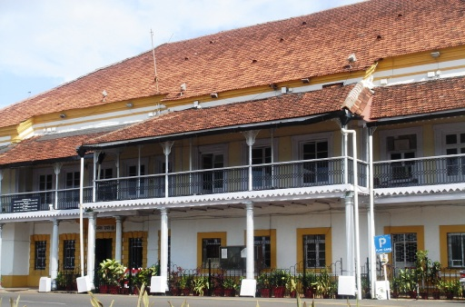
Breakfast at the hotel

Transfer to a Homestay

Overnight at the hotel

04 Jan Fri AROSSIM

Breakfast at the hotel

Half day tour of spice plantation, with the most delicious organic lunch included. Here they grow almost all kind of spices except saffron and you would be explained the significance of each. After plantation, if interested visit (if in stock) the cashew nut processing factory. If interested also visit one of the Hindu temples (Shantadurga or Mangueshi)

Overnight at the hotel

05 Jan Sat AROSSIM

Breakfast at the hotel

Day is free to relax

Overnight at the hotel

06 Jan Sun AROSSIM

Breakfast at the hotel

Day is free to relax, explore town on own, do shopping, etc

Overnight at the hotel

07 Jan Mon AROSSIM - ****

Breakfast at the hotel

Transfer to the airport
**** Departure by flight ** – ****

========= END OF A MEMORABLE TRIP =========
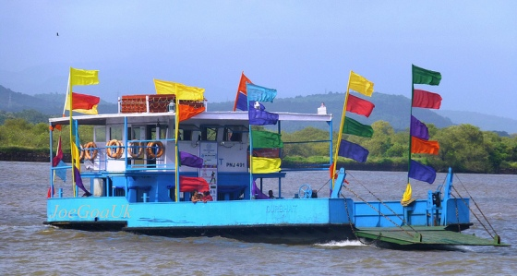

Price on Double Occupancy: GBP Per Person X 4 Persons

Rates are Inclusive of:

- Accommodation on twin sharing, Bed & Breakfast basis, for 10 nights as per given room categories however, houseboat is on full board (all meals included)
- All transport for transfers and sightseeing by AC Toyota Innova car. The airport transfers will be with assistance of Representative
- All entrance fees for the sights visited, as mentioned in the programme
- All Goods & Service Taxes (GST) as being charged by the government
- Printed itinerary, maps and colourful picture postcards for each member

Rates however do not include:

- Any items of personal nature such as tips, beverages, laundry and telephone calls, etc
- Any international air fare or visa fees
- Any domestic air ticket

NOTE: The final offer may change in future owing to any change in tax structure by the Government and / or due to big fluctuation in currency exchange rate

